

# Welcome

Welcome

This report presents South Ribble Council’s annual report for 2021/22. It provides an overview of activities and achievements over the last 12 months, outlining the key steps that we have taken to ensure that we continue to deliver our vision and priorities as outlined below:

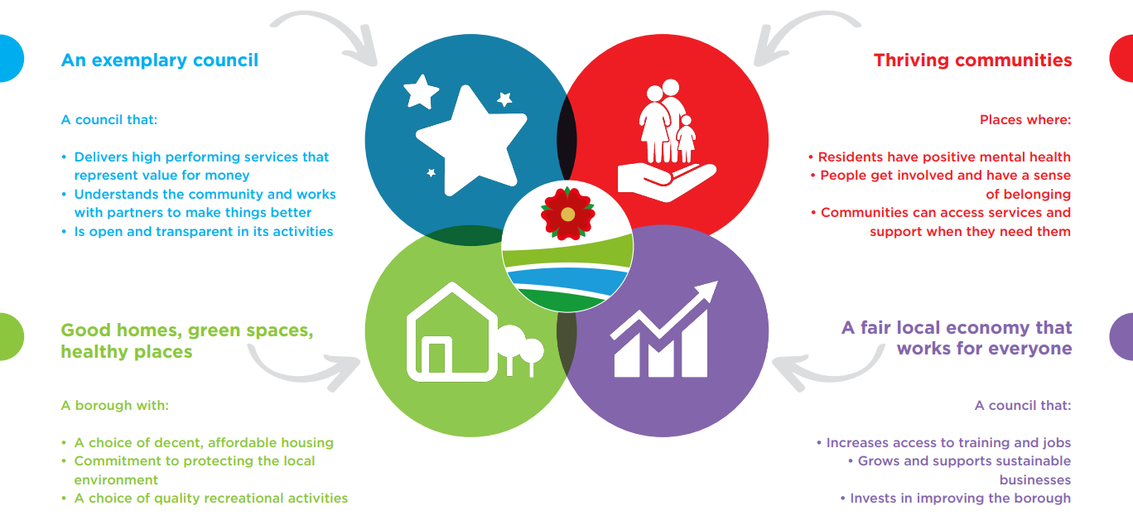

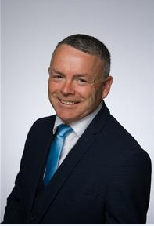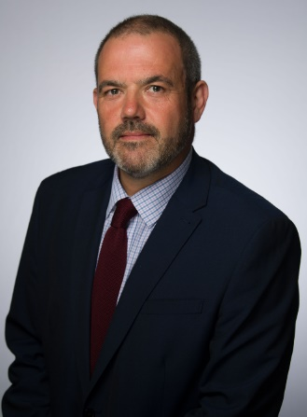 **Introduction**

Introduction

**From Councillor Paul Foster, Leader of the Council, Cabinet Member (Strategy and Reform)**

I am proud to present this report which highlights how much we have achieved over the last twelve months. We have worked hard to help our borough recover from the pandemic and continue to offer vital support though the South Ribble Together Community Hub, our holiday hunger initiatives and through support to our local businesses.

We are committed to better outcomes for our residents, communities and businesses, investing over £14k to fund community projects through the Community Boost Fund. Additionally, we have taken advantage of £270k government funding through the Household Support Fund to support those most in need. Overall through the council, £9.5 million has been delivered in Covid-19 business support grants. Looking to the future, the council has committed over £500k as part of the ‘Boost Fund Plus’ to support local communities to thrive and the ‘Leisure Local Community Fund’ focused on making recreation, leisure, and sport opportunities accessible to everyone As a community leader, we have continued to lead the way to address climate change by planting over 34,000 trees this year and overall the council has planted a total of 96,671 trees across the borough.

We continue to work closely with our partners, communities, and businesses to make South Ribble the great place to live for everyone, as we move forward with ambition for the future.**Overview of Resources**

**From Councillor Matthew Tomlinson, Cabinet Member (Finance, Property and Assets)**

Despite a challenging year for both our colleagues and communities, we have continued to deliver our key corporate priorities and provided high quality services to our residents.

Looking forward, there is a huge amount of uncertainty regarding future Government funding and the cost of living, however we have plans in place to meet the financial challenges and will continue to transform services to deliver efficiencies as well as investing in capital expenditure projects throughout the borough.

Over the next year we will be delivering a programme of early intervention to support positive mental health for young people, deliver neighbourhood improvement projects and a programme of improvements to community facilities. In addition, we will be focusing on the completion of major developments such as the McKenzie Arms scheme delivering good quality affordable homes, investing in our leisure centres and Worden Hall, and progressing the Leyland Town Deal to renovate the town centre, providing essential facilities for our residents and businesses.

We will continue to make the best use of resources to deliver the priorities of the Council in response to the needs and expectations of our residents.

“We continue to work closely with our partners, communities, and businesses to make South Ribble the great place to live for everyone, as we move forward with ambition for the future.”

# Over the year in 2021/22 we…

Business as usual

|  |  |
| --- | --- |
| Answered **1704 calls each week** through the council’s contact centre | Computer with solid fill  Received **730** **requests each week** via our online self-serve |
| Recycled **378** **tonnes each week** of household waste | Planted **664** **trees each week** across the borough |
| Delivered **over** **£14k each week** ofDisabled Facilities Grants | House with solid fill  Prevented **24 people each month** from potentially becoming homeless |
| Contract with solid fill  Processed **89** planning applications **each month** | Internet with solid fill  Received over **2368 visits each week** to the council’s website |
| Handshake with solid fill  Processed **61** Covid-19 business support grant **each week** | Bank check with solid fill  Processed **£184k** **each week** in Covid-19 grants |

# Resident’s Survey

Residents Survey

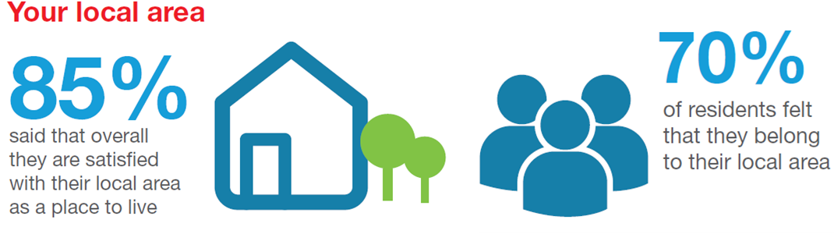

In 2021, we conducted a survey which asked residents about the local area and the impact of the pandemic. The survey received a total of 1,191 responses.

The responses and findings from the residents’ survey help us improve services and shape future priorities. We are investing in existing leisure facilities, community facilities, and open space and play areas.

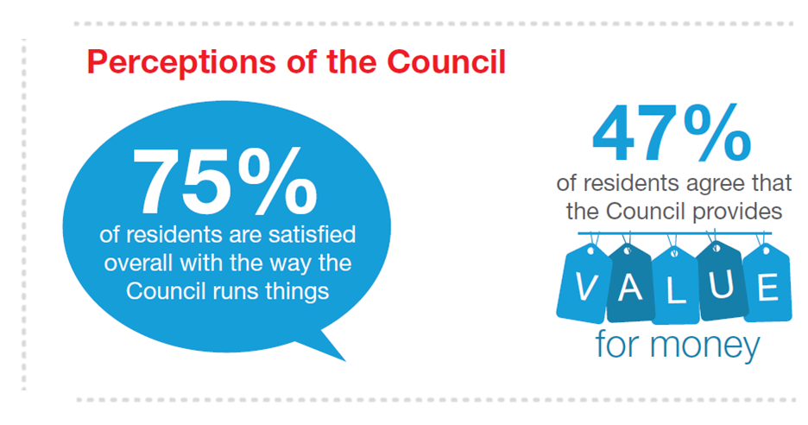

|  |  |  |  |
| --- | --- | --- | --- |
|  | **AN EXEMPLARY COUNCIL** | | |
| **Delivers high performing services that represent value for money** | | **Understand the community and work with partners to make things better** | **Is open and transparent in its activities** |

Delivering the council's priorities

|  |  |
| --- | --- |
|  | **Key Achievements 2021/22** |
| * **16%** increase in the number of service requests received via self-serve channels * **85%** of people satisfied with South Ribble as a place to live | |

|  |
| --- |
| The Chorley and South Ribble Partnership hosted its first Economic Summit in November 2021, where local businesses and partners were invited to discuss the future of the local economy following the impacts of the pandemic. The event involved over 100 stakeholders and a range of key leaders and organisations, including Runshaw College, Lancashire Enterprise Partnership and BAE Systems. The outcomes from the summit will shape future economy interventions as part of an ongoing dialogue with local businesses. |

|  |
| --- |
| A picture containing text, clipart  Description automatically generatedWe have completed phase two of shared services with Chorley Council, which has involved the sharing of ICT and Customer Services. This will increase resilience, share expertise, create opportunities for staff and reduce operating costs as part of continuously improving our operations and service delivery. It will ensure that our customers received better value for money and efficient services, with £179k saved over 2021/22. |
| We completed a residents’ survey to find out how satisfied residents are with the services the council provides and the borough as a place to live. 85% of residents said they are satisfied with their local area as a place to live, and satisfaction with the way the council runs things has improved since the last survey in 2020.  Satisfaction with council services has increased with improved responses on waste and recycling collection (83%), keeping land clear of litter and refuse (65%), and park and open spaces (79%) in their area. Overall, the response from residents has been very positive despite recent challenges of financial pressure and the impact from the pandemic. |

|  |
| --- |
| As part of the council’s continued commitment to improvement, a virtual Corporate Peer Challenge from the Local Government Association (LGA) was undertaken in July 2021.The peer team recognised the positive work and outcomes in relation to governance, delivering effective services throughout the pandemic and continuing to change ways of working. Following the review, a report was published along with an action plan setting out how the council would respond to the recommendations. The action plan was implemented, and key actions successfully delivered ahead of the peer team six-month revisit to check up on progress in April 2022.  The peer team found that the council responded positively and made fundamental improvements across the areas of governance, performance improvement and people management. The peer team commended the council’s relationship with communities and highlighted the Community Hub model as a positive approach that should continue to be taken forward and developed further. |

|  |  |  |  |
| --- | --- | --- | --- |
|  | **Thriving Communities** | | |
| **Residents have positive mental health** | | **People get involved and have a sense of belonging** | **Communities can access services and support when they need them** |

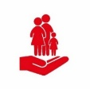

Delivering the council's priorities

|  |  |
| --- | --- |
|  | **Key Achievements 2021/22** |
| * **11,046** residents participated in activities delivered by the Council * Over **£14k** spenton community projects through the Boost Fund | |

|  |
| --- |
| As part of the council’s commitment to supporting resident’s positive mental health and wellbeing, Lancashire Youth Challenge was commissioned to deliver a 24-week programme to up to 20 young people, and focused on raising young peoples’ aspirations, confidence building, and the development of emotional resilience. |

|  |
| --- |
| To mark the Queen’s Platinum Jubilee, the council hosted a weekend of entertainment over the extended Bank Holiday in June 2022. Events were held at Worden Park, and included a Great British themed Leyland Festival, followed by the 80’s themed ‘Music in The Park’ concert, attended by 3,000 people. The extended bank holiday weekend was a major success with overall attendance for the events estimated to be between 15,000 and 20,000 combined. In addition, the council supported local communities to celebrate with grants of over £9,300 to support community groups and street parties across the borough. The events provided a great opportunity to celebrate the Queen’s Jubilee marking 70 years of service to the people and brought local communities together, as well as supporting the local economy following the pandemic and restrictions placed on everyone during that period. |

|  |
| --- |
| The review of the Community Hubs provided a positive outlook with over 85% of members reacting favorably to questions regarding the support and engagement in relation to the Community Hubs.  Action plans for each of the community hub areas were agreed earlier in the year and progress made against delivery. Examples of some projects being delivered include disabled access improvements to the Eagle and Child Bowling Club, delivery of South Ribble in Bloom, resocialisation/social isolation interventions such as chatty cafes, installation of happy to chat benches, and invested more than £25,000 to install Automated External Defibrillators (AEDs) across the borough.  As part of the council’s commitment to developing communities, an investment of over £14k has been made to fund a number of projects through the Community Boost Fund. These include the ‘Love Where you Live’ campaigns, working with local schools to design banners and posters to prevent dog fouling and littering, ‘Penwortham Welcome’ (Deer Monument) and Coach House Christmas event, and Garden Angels (DBS checked volunteers support vulnerable residents to maintain their gardens). |

|  |
| --- |
| A picture containing clipart  Description automatically generatedThe council working with the Football Foundation has invested in the creation of two new 3G artificial sports pitches at Bamber Bridge Leisure Centre. The pitches will be complimented by a fully-accessible single-story pavilion that will include four new changing rooms with showers, a separate disability accessible changing facility and changing rooms for officials. Additionally, the existing Leisure Centre car park will be extended to provide a total of 206 spaces. The development of these much needed facilities will support residents to become more active though participation in sport. |

|  |  |  |  |
| --- | --- | --- | --- |
|  | **A FAIR LOCAL ECONOMY THAT WORKS FOR EVERYONE** | | |
| **Increases access to training and jobs** | | **Grows and supports sustainable businesses** | **Invests in improving the borough** |

|  |  |
| --- | --- |
|  | **Key Achievements 2021/22** |
| * **351** businesses were referred/supported by the council * **£9,578,526** was paid out in 2021/22 for Covid-19 business support grants | |

Delivering the council's priorities

Delivering the council's priorities

|  |
| --- |
| Icon  Description automatically generatedPlans have taken shape for Leyland’s £25 million Town Deal, with the scheme reaching its final planning stage. Land acquisitions have commenced, and business cases submitted to central government for two key projects.  The projects which aim to renovate the town centre include the Town Centre Transformation (including Market Regeneration), and the Business Advice, Skills and Enterprise Hub (BASE 2). Consultations have taken place with stakeholder to support delivery of the scheme, with more planned over 2022. The project is subject to the approval of the business cases, with the aim to deliver the Town Deal scheme by the year 2026. |

|  |
| --- |
| The first round of the Household Support Fund (HSF) was delivered to support the most vulnerable residents from the economic pressures facing communities as they recovery from the pandemic.  Over 3,000 residents were able to benefit from the £270k fund, which provided support with adaptations to make homes more energy efficient, fresh food vouchers, school uniforms, access to white goods, and financial support with utility bills. |

|  |
| --- |
| Icon  Description automatically generatedThe council received an additional £706k of funding from Central Government, as a result of its perfomance in meeting key targets on advancing covid support grants to businesses. This additional funding was combined with the councils exsiting commitment to invest £150k to support businesses.  Overall through the council, £9.5 million has been delivered in Covid-19 business support grants to over 3,000 businesses. The additional support provided through the funding from the council enabled351 businesses to be referred/supported with a range of interventions such as business start-up and growth advice, information on available commercial space and council land/premises, support with planning issues, business rates information, environmental health advice, mental health support, digital support and coronavirus business support. |

|  |  |  |  |
| --- | --- | --- | --- |
|  | **GOOD HOMES GREEN SPACES HEALTHY PLACES** | | |
| **A choice of decent, affordable housing** | | **Commitment to protecting the local environment** | **A choice of quality recreational activities** |



Delivering the council's priorities

|  |  |
| --- | --- |
|  | **Key Achievements 2021/22** |
| * **290** people were prevented from being/becoming homeless * **34,504** trees were planted across the borough * **86** affordable homes delivered | |

|  |
| --- |
| The council continues to tackle climate change. A significant achievement was completion of the installation of solar panels at the Civic Centre enabling the council to contribute to generation of clean renewable energy, whilst reducing the council’s energy costs and importantly lowering our carbon footprint. Across the borough we have continued to expand the green infrastructure with the installation of four electric vehicle charging points across Leyland, Bamber Bridge, Lostock Hall, and Penwortham, the planting of 34,504 trees across the borough, and improvements to 8km of footpaths across the green links network. |

|  |
| --- |
| Icon  Description automatically generatedThe development of the McKenzie Arms and Jubilee Gardens Extra Care schemes have come forward to increase the access to high quality affordable, safe homes. Construction commenced onsite at the McKenzie Arms and will be completed at the end of 2022, providing a mix of 15 affordable townhouses and apartments in Bamber Bridge. The Jubilee Gardens Extra Care Scheme has progressed to planning approval stage and will provide self-contained homes with support services to the over 55’s to support independent living. The scheme is currently being brought forward with design works and the appointment of a contractor to deliver the scheme. |

|  |
| --- |
| Investment in Worden Hall at the heart of Worden Park, has seen the space transformed and will soon be open to the public, bringing back into use once more a well-loved facility as an accessible flexible community and event space.  The development work to the hall has included the expansion of the Folly Café, which moved to its new home in the heart of the hall in May 2022. This move enhances the catering and hospitality offer at the hall. Other works completed include upgrades to the foyer, refurbishment of the Marsden Room and first floor rooms into a flexible event space, demolition of the conservatory, works to the Courtyard Hall, extension of the car park and improvements to surrounding landscape.  Refurbishment works to the hall are largely complete and was partially opened ahead of the Leyland Festival in June 2022. It is expected that the Hall will be fully open to the public from mid-September 2022, with bookings for events taking place from spring. |

# Investment

Investment

The council has continued to invest in improvements right across the borough that have helped deliver better long-term outcomes for residents in 2021/22.

An exemplary council

|  |  |  |  |  |
| --- | --- | --- | --- | --- |
|  | **£500,000** over the next two years to deliver a programme of improvements to community facilities providing quality amenities for residents, encouraging positive mental and physical health as part of an active community |  |  | **£50,000** to support positive mental health for young people through officer resource to deliver a programme of early intervention activity |

Thriving communities

|  |  |  |  |  |
| --- | --- | --- | --- | --- |
|  | **£60,000** to support vulnerable families and children by providing access to food during the school holidays over the next four years |  |  | **£117,000** invested to create a network of community hubs, providing services & support that meet the needs of local neighbourhoods |
|  |  |  |  |  |
|  | **£50,000** to support access to advice services and information by working in partnership with the Citizens Advice Bureau |  |  | **£150,000** to develop a Credit Union that will enable access to safe and ethical banking options for all residents |

Good homes, green spaces, well places

|  |  |  |  |  |
| --- | --- | --- | --- | --- |
|  | **£2,000,000** invested to deliver affordable housing. |  |  | **£50,000** to undertake work to plan for an Extra Care scheme that will provide high quality accommodation to meet the future needs our residents. |
|  |  |  |  |  |
|  | **£250,000** to support action on the green agenda including tree planting (in addition to A Tree for Every Resident), becoming a green employer by 2022 and installing car charging points as part of infrastructure improvements |  |  |  |

A fair local economy that works for everyone

|  |  |  |  |  |
| --- | --- | --- | --- | --- |
|  | **£500,000** to deliver neighbourhood improvement projects including: - Development of a nature reserve at Pickering’s Farm - Tidy up of community areas in Pope Lane area - Improvements to Kingsfold Community Centre and playing fields - More dog bins and relevant signage |  |  | **£150,000** to implement a plan to retain wealth and grow the local economy through a progressive procurement framework and social value policies. |
|  |  |  |  |  |
|  | **£150,000** to deliver an extended programme of support for businesses beyond government grants to ensure that the council is doing as much as possible to help businesses get back on their feet. |  |  |  |

Investment

# Over the next year we will need to consider:

Future Challenges

# Looking ahead

Looking Ahead

Going forward, we will continue to focus on delivering positive outcomes for residents. Some of the key projects that we will be delivering over 2022/23 include

|  |  |  |  |  |
| --- | --- | --- | --- | --- |
|  | **Develop the Youth Council to make sure the views of young people are represented**  This project will take forward the work of the Youth Council with a programme of meetings and an action plan to increase democratic participation across young people. |  |  | **Review and enhance the community hubs as a primary way to work closely with residents**  This project will deliver the community hub action plans and ‘boost’ fund to enable more to be achieved to meet local priorities and a review and evaluation of community hubs. |
|  | **Deliver Music in the Park 2022 and Queens Jubilee Celebrations**  This project will deliver the celebration events in 2022. |  |  | **Develop the visitor offer in South Ribble**  We are going to create a tourism strategy for South Ribble with a new campaign to promote the borough as we recover from the pandemic. |

|  |  |  |  |  |
| --- | --- | --- | --- | --- |
|  | **Deliver the peer challenge action plan to ensure continued improvement**  This project will put in place actions to respond to the recommendations made by the Local Government Association Corporate Peer Review. |  |  | **Implement more efficient and effective working practices at the council through the WorkPlace Strategy**  This project will deliver the Workplace Strategy and year one actions to improve the office environment and the way that staff work. |
|  | **Deliver the shared services development plan to build a more resilient organisation**  This project will deliver each shared service development plan to establish strong processes and a positive working culture. |  |  | **Deliver more joined up public services through working with our partners**  This project will work with partners to join up services so that they make more sense for residents through better sharing of intelligence, more integrated structures. and reduced duplication. |

:

|  |  |  |  |  |
| --- | --- | --- | --- | --- |
|  | **Green Agenda:****Lead action to address climate change for South Ribble**  The council will lead activity to address climate change and encourage residents to make positive changes with specific actions including the decarbonisation of council assets, electrification of the council vehicle fleet, and improving recycling. |  |  | **Improve leisure facilities in South Ribble to improve wellbeing**  This project will improve the current leisure services to provide a better offer and user experience to increase overall wellbeing. |
|  |  |  |  |  |
|  | **Deliver affordable homes**  This project will deliver the affordable homes project at the McKenzie Arms and progress the development of the Extra Care facility. |  |  | **Deliver the new Worden Hall complex as a flagship venue**  The new Worden Hall complex will be completed and opened at the end of 2022. |

|  |  |  |  |  |
| --- | --- | --- | --- | --- |
|  | **Deliver transformational regeneration projects including the Town Deal**  This project will deliver the Town Deal but also include other regeneration plans for other local service centres. |  |  | **Support communities to access community cooperatives in South Ribble as part of growing a fair local economy**  As part of Community Wealth Building, this project will identify with communities and test a community-led approach to accessing goods or services such as a food sharing network or an energy collective. |
|  | **Support residents to recover from the pandemic with advice, support, and key services**  This project will provide a ‘One Front Door’ response for residents in need of support with debt, employability or housing by providing a single point of access to a range of council and partner services so that they don’t have to go to lots of different places for help. |  |  |  |

Looking Ahead

**Appendix A - Trade Union Facilities time for 2021/22 South Ribble Borough Council**

Appendix A

The trade Union (Facility Time Publication Requirements) Regulations 2017 came into force on 1 April 2017. These regulations place a legislative requirement on relevant public sector employers to collate and publish, on an annual basis a range of data on the amount and cost of facility time within their organisation. The facility time data for South Ribble Borough Council for the period of 2020/21 is shown below. We have included the tables to illustrate the information required, and it is published alongside the Annual Report for the period 2020/21.

|  |  |
| --- | --- |
| Number of employees who were relevant  union officials during the relevant period | Full-time equivalent employee number |
| 9 | 6 |

**Table 1 - Relevant Union Officials**

What was the total number of your employees who were relevant union officials during the relevant period?

**Table 2 - Percentage of time spent on facility time**

|  |  |
| --- | --- |
| Percentage of time | Number of Employees |
| 0% | 0 |
| 1-50% | 9 |
| 51-99% | 0 |
| 100% | 0 |

How many of your employees who were relevant union officials

employed during the relevant period spent a) 0%, b) 1%-50%,

c) 51%-99% or d) 100% of their working hours on facility time?

**Table 3 - Percentage of pay bill spent on facility time**

|  |  |
| --- | --- |
|  | Figures |
| Provide the total cost of facility time (including oncosts) | £6,699 |
| Provide the total pay bill | £12,374,997 |
| Provide the percentage of the total bill spent on facilities time | 0.05% |

Provide the figures requested in the first column of the table

below to determine the percentage of your total pay bill spent

on paying employees who were relevant union officials for

facility time during the relevant period.

|  |  |
| --- | --- |
| Time spent on paid trade union activities as a percentage of the total paid facilities time hours | 0 |

**Table 4 - Paid trade union activities**

As a percentage of total paid facility time hours, how many

hours were spent by employees who were relevant union

officials during the relevant period on paid trade union activities?

